

**Saving Your Files Stored in Google Drive- For Students**

1. **Saving Google Files you have in MYBLUEPRINT**

Video Instructions

[Saving files from MBP.mp4](https://abbyschools.sharepoint.com/:v:/s/CurriculumSupportResources/EYnT9PlMPe9CkHc5l8J4Qo4BJjZzJ6H1ElihuaL_5FrT6w?e=FRCE4y)

Written Instructions

1. Log into your Google Drive and create a folder called “! Files I Want to Keep”. The “!” at the front of your folder name will put it at the top of your Google Drive and will make it easier to find.

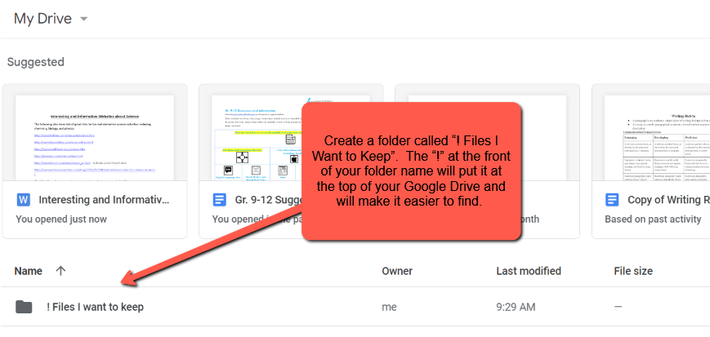

1. Log into your MyBlueprint account using your regular log-in (Learn34); Click on the “Portfolio” tab.

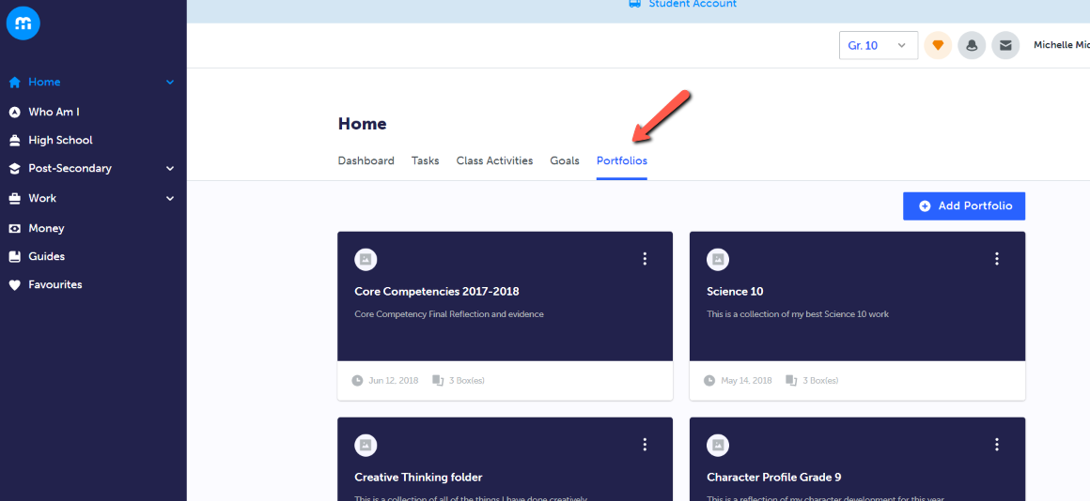

1. Select a portfolio to view:

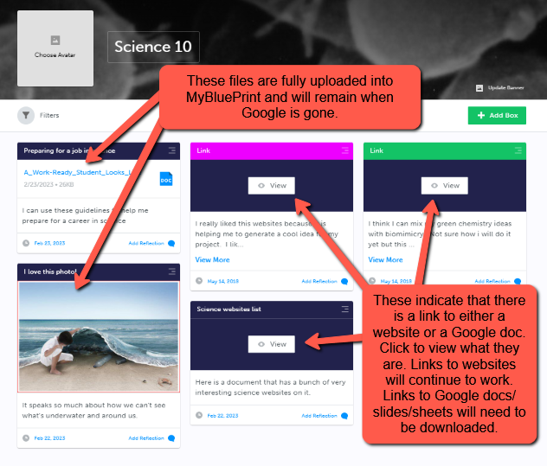

1. Click each “View” to see what is hyperlinked to this box.

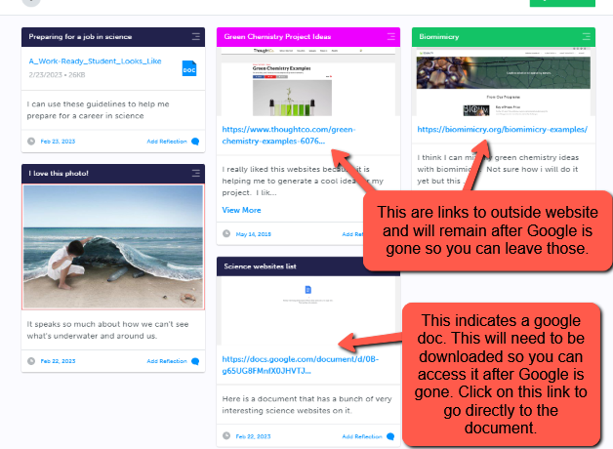

5. Click on the Google doc link to go directly to your Google doc. Click “File” then select “Move”

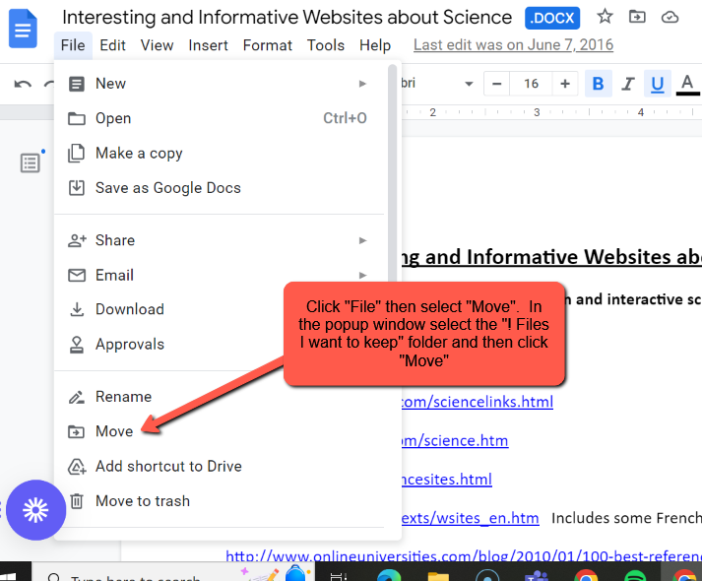

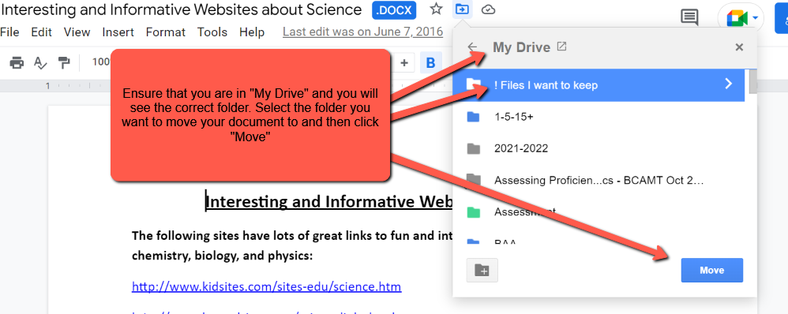

Continue this process until you have located all of the Google docs, slides, or sheets that you want to continue to view, use, and/or edit after Google is gone and put them into the “! Files I want to keep” folder. You can also use this folder for other documents that are not in MyBlueprint but you will want to use for your future Capstone or other projects.

Once you have selected all the files you want to keep, **download the whole folder** to either a **memory stick/drive,** if you are using a Chromebook, or download it onto your home computer desktop. You will then be able to upload those files into your OneDrive folder.

1. **Saving files you have in Google Drive**

**Tips for how to save my Google Drive files** – [learn more here](https://abbyschools-my.sharepoint.com/:p:/g/personal/debbie_born_abbyschools_ca/EU04AuKVvnlJiocnTO4nNfsBIXyzunLNo8lW-MXCU2j5Ig?e=SHHBdk) (written tips + a video)